Available online at [www.sciencedirect.com](http://www.sciencedirect.com/)



AASRI Procedia 3 (2012) 495 – 500

2012 AASRI Conference on Modeling, Identification and Control

Research on power grid reasoning expert system based on ontology

Ke Dua, Weimin Lina, Jinghong Guoa, Feng Huanga, Li Huanga

*a Department of Information and Communication, China Electric Power Research Institute, Nanjing City, Jiangsu Province, 210003, China*

Abstract

Power Grid reasoning expert system is a complex system. To solve knowledge sharing of knowledge Base in expert system, we abstract and analyze the power grid security investigation procedure by using ontology Technology. With ontology-based Power Grid knowledge base, we establish associated relationship of procedure vocabularies. In this paper, we introduce and analyze of semantic reasoning tools such as Jena. The reasoner mechanism and inference rules of grammar has been included and explained. At last we give a specific application of security investigation procedure ontology and reasoning.

© 2012 The Authors. Published by Elsevier B.V. Open access under [CC BY-NC-ND license.](http://creativecommons.org/licenses/by-nc-nd/3.0/)

© 2012 The Authors. Published by Elsevier B.V.

Selection and/or peer review under responsibility of American Applied Science Research Institute

Selection and/or peer review under responsibility of American Applied Science Research Institute

*Keywords:* Power grid, Knowledge base; Ontology; Jena; Introduction

With the information technology of the State Grid Corporation of increasing input level, as well as the economic and social benefits of information technology gradually revealed more and more industry business information technology to provide supervision and services. But at the same time, the smart grid construction in China's 12th Five-Year Plan on the ability of information technology put forward higher requirements, from the point of view of the development of the grid overall information technology to provide the set of consulting, planning, development, integration, training, operation and maintenance in one of the full-service, to improve knowledge sharing and reuse. Therefore, the establishment of the grid information technology knowledge base to become a top priority.

According to the business needs of power grid, the grid knowledge base content, including: standards, laws and regulations, business models, data models, application software components and solutions, eight categories of information analysis and information technology panorama. The entire power grid or system

2212-6716 © 2012 The Authors. Published by Elsevier B.V. Open access under [CC BY-NC-ND license.](http://creativecommons.org/licenses/by-nc-nd/3.0/) Selection and/or peer review under responsibility of American Applied Science Research Institute doi:10.1016/j.aasri.2012.11.078

software, according to some classification splits, combinations, knowledge base stored in a certain way, for in the development of similar systems in the future, retrieved from the knowledge base associated knowledge. Good split between the component or model complex relations, how to organize, store these components or model, so that it can correct and fast retrieval of desired content is the key to building a grid information technology knowledge base [1]. If we only use a traditional relational database to store the table structure is difficult to express the various relationships, and where the relational database is difficult to represent knowledge in semantic hierarchical relationships (such as the relationship between transitivity). Ontology is the explicit formal specification of a shared conceptual model, a clear and formal way to represent the domain knowledge to improve the interoperability between heterogeneous systems, and promote the sharing of knowledge, which can solve the problems [2].

This paper constructs a grid knowledge base by using the ontology ideological. Not only a clear description of power grid knowledge base concepts and their relationships, but also achieve of power grid knowledge sharing. This is conducive to the management and maintenance of the power grid knowledge base. Build ontology and use the ontology for the power grid, conducted ontology-based semantic search, so as to improve the recall and precision, which requires parsing and ontology reasoning. While there are a lot of ideas and tools of the body parsing and reasoning. Currently, the main tools are Jena, HermiT, Racer, Jfact, FaCT +

+, Pellet and etc. We can even write our own ontology parsing module. The inference mechanism is built on Jena in this paper.

1. Ontology-based reasoning technology

In order to solve the problem of sharing of knowledge information, researchers in the field of information has introduced information ontology. Studer [3] summarized information ontology contains four areas: conceptualization (Conceptualization), clear (Explicit) formal (Formal) and the shared). If we only use natural language or written expression of geographic information services, it is easy to produce fuzzy. So we often used the formal ontology explicitly geographic information services semantic information. At the same time, service providers and service users from different industry backgrounds will lead to a different understanding, which both have the same meaning service and service heterogeneous phenomenon. Hakimpour [4] divided ontology into four categories: the heterogeneity of the conceptual model, spatial model of heterogeneity, the structural heterogeneity and semantic heterogeneity. Due to the characteristics of Web services technology has to solve the conceptual model, space model, and the heterogeneity of the structure, this article discusses only the service semantic heterogeneity problems. In order to achieve the classification management of massive geographic information services, this paper established semantic relationships between the service concepts. Common semantic relations including hyponymy relations and score relationship, the kind-of and part-of, respectively hyponymy relationship between the concept and the total score relations [5]. Ontology structure definition is still a lack of unified standards, generally determined depending on the context. More widely used method four elements of the traditional methods and newer six-tuple representation [6][7].

Parsing and reasoning process of the ontology, usually involves reasoning problems including:

1. Class (concept) / instance relationship reasoning. Given knowledge base K; C is a class K (concept); i is individual K. Available on the relationship of the following classes and instances reasoning: to determine whether an individual is an instance of C; judgment in all instances of the K of C; judgment which instance of the class K in individual i; relationship between two instances of judgment or judgment of an instance of a specific instance.
2. Class (concept) reasoning. Given class C and D, and to determine the relationship between them (subclass members, partial).
3. In the architecture of the classes for inference. Given class c, back in the K of C or superclass; returned in the K of C or subclass.
4. meet reasoning. Given a class C, to determine the C in K is satisfied (the same).
5. The property-based reasoning. Attribute class (instance) similar reasoning, including: property/instance relationship attribute contains the attribute architecture and properties to meet.
   1. *Components of ontology parsing and reasoning (Jena)*

Jena is an API for RDF and OWL, OWL and RDF inference the Jena core only provides limited query primitives. Reasoning Jena itself is a rule-based inference engine to achieve, by the rules of OWL reasoning are very complete, not all OWL-DL reasoning functions support, Jena storage of the knowledge base and even persistent support (the knowledge base can be directly present in a relational database). The new version of the Jena 2.2 has begun to support the integrated use DIG interface Reasoner. According to actual needs, take advantage of Jena development kit inference ontology model application. The Jena reasoning machine system and Ontology subsystem basic core architecture, its specific structure mainly includes:

* + 1. RDF API (com.hp.hpl.jena.modelb package). For RDF files and mold processing.
    2. body parser. Parse the file based on XML syntax for RDF, RDFS, OWL.
    3. RDF model of persistent storage solutions.
    4. Reasoning the subsystem (com.hp.hpl.jena.reasoner package). For the retrieval process of reasoning, this reasoning is based on the rules.
    5. Ontology subsystem. For the handling and operation of the Ontology, it OwL, DAML +O IL RDFS provides a different interface support.
    6. SPARQL query language. Query search for information.

The function of component in semantic retrieval is shown in Fig.1.



RDF Model

Jena InfModelOntModel

RDQL

Ontology Model

Reasoner Model

RDF API

XML Doc Parser

OWL/RDF Doc

Search Result

Fig.1 Function of component in semantic retrieval

In general, we build the Protege such editor ontology. We will want to use it in the application which requires some development interface. The procedure body is necessary, because in many cases, we would like to automatically generate the ontology. Protege created by hand is all ontology is unrealistic. Jena is a the HP developed such a set of APIs, the HP company seems to go very front in this regard in the body, and other large companies are still waiting to see this? It can be said, the Jena application like Protege for us, we use the Protege operating body, the application is used to do the same work in Jena, of course, these applications still have to write. In fact, the Protege in itself is developed on the basis of Jena, you see Protege's console reported abnormal, and Jena will likely be relevant. Recently a Protege OWLAPI, to the equivalent of Jena's packaging.

* 1. *Reasoning mechanism*

The semantic retrieval can be achieved by using the relationship between concepts in semantic level. The key is inference of relationship. Jena prove reasoner which is based on first-order logic rules. Rule-based inference engine, including RDF reasoner, RDFS reasoner, OWL reasoner, and it contains a general inference. We can also custom inference rules needed register to use third-party inference engine. Reasoning mechanism is shown in Fig.2.

Fig.2 Mechanism of the inference

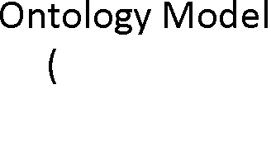

The inference engine works as follows:

(1) Reasoning registration mechanism to create basic RDF triples and ontology reasoning machine. (2) The inference engine can generate a model object that contains the inference mechanism. (3) Model API or Ontology API model for handling and processing.

When to use the "reasoning registration create inference engine, there are three ways:

1. A general rule-based inference engine that comes with Jena, such as RDF reasoner and OWL reasoner. OWL Reasoner, for example, the solution is: Schema files for Schema Model to create the inference engine, combined with the Instance Data Model Instance documents obtained to create an integrated information resource and of Ontology reasoning mechanism available the final inference engine.
2. Based on custom rules inference engine. The inference engine to create user-defined rules, to be added to custom rules Jena inference engine, and create a data model that contains the reasoning relationship.
3. The use of third-party inference engine. Refers to the third-party reasoning rack in Jena on top,
4. Application in power grid

Reasoning techniques on the basis of support for a particular field of knowledge Ontology as a field of knowledge base, for example, is now part of the power grid security investigation procedure ontology. Ontology of power grid security investigation procedure is show in Fig.3.

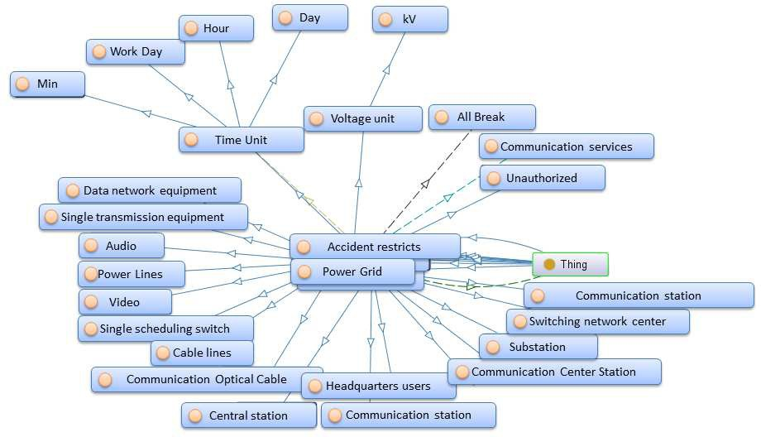

Fig.3 Contents of the power grid security investigation procedure ontology

Application accesses the inference machinery by using the ModelFactory to associate a data set with some reasoner to create a new Model. Queries to the created model will return not only those statements that were present in the original data but also additional statements than can be derived from the data using the rules or other inference mechanisms implemented by the reasoner.

As illustrated the inference machinery is actually implemented at the level of the Graph SPI, so that any of the different Model interfaces can be constructed around an inference Graph. In particular, the Ontology provides convenient ways to link appropriate reasoners into the OntModels that it constructs. As part of the general RDF API we also provide an InfModel, this is an extension to the normal Model interface that provides additional control and access to an underlying inference graph.

1. Conclusion

As open resources project which developed by HP Labs, Jena is a powerful tool to achieve semantic reasoning, research and one of the basic tools for semantic retrieval. Learning and Jena, not only help to deepen the understanding and awareness of the Ontology knowledge, but also can improve the retrieval efficiency. Therefore, Jena as a support tool for semantic reasoning later ontology research process has a very important role.

References

1. Brest T, A Semantic Web Framework [Z].(2004.10.12).
2. Seabone A, A Programmer's Introduction to RDQL [Z]. (2004.10-17).
3. Studer R, Knowledge engineering:Principle and methods [J]. Data & Knowledge Engineering, 1998, 25(1- 2) : 161-197.
4. Hakimpour F, Timpf S, Using ontologies for resolution of semantic heterogeneity in GIS[C]. Citeseer, 2001.
5. Buccella, Cechich A, Fillottrani P. Ontology-driven geographic informalion integralion: A survey of current approaches[J]. (computers &. Geosciencei, 2009, (4Sp. Iss. SI): 710- 723.
6. Golfarell M, Proli A, Rizzi S. M-FIRE: A metaphor-based framework for in formalion representation and exploration[A]. WEBIST 2006: Proceedings of the Second Irnernalional Conference on Web Information Syslems and Technologies, Internet Technology/Web Interface and Applications[ C]. 2006. 332- 340.
7. Neuman Y, Nave O, Metaphor-based meaning excavation[J]. Information Sciences, 2009, 179(16):2719- 2728.

Contact of Corresponding Author:

Name: Du Ke

Email: [duke@epri.sgcc.com.cn](mailto:duke@epri.sgcc.com.cn) Mobile: 18651908359